**[PRE REQUISITES](https://careereducation.smartinternz.com/Student/guided_project_workspace/45974" \l "collapse1)**

**Software download**

|  |  |
| --- | --- |
| **Team ID** | **PNT2022TMID47589** |
| **Project Name** | Personal Assistance for Seniors who are Self-Reliant |

**Python Installation:**

1.Search in google engine as **download python.**

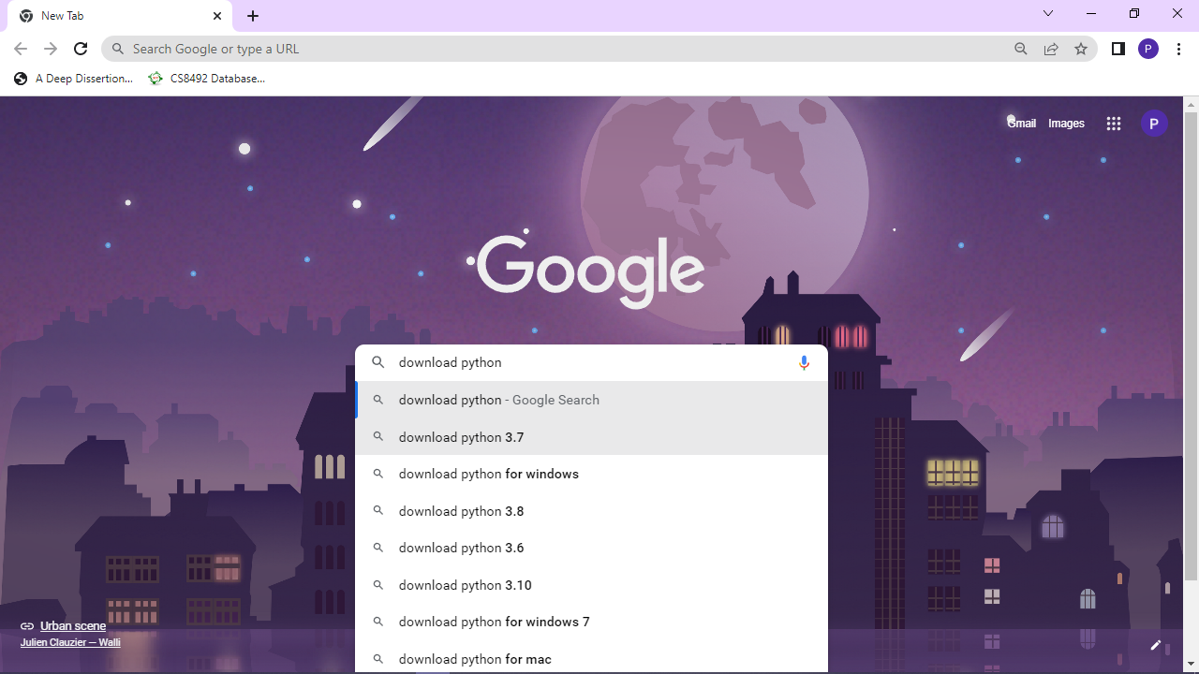

Step 2: Click Download python

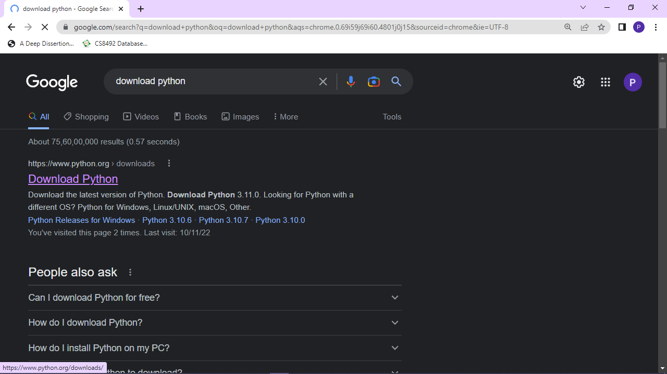

3.Click the download Python3.11.0.After downloading click python-3.11.0-amd64.exe .

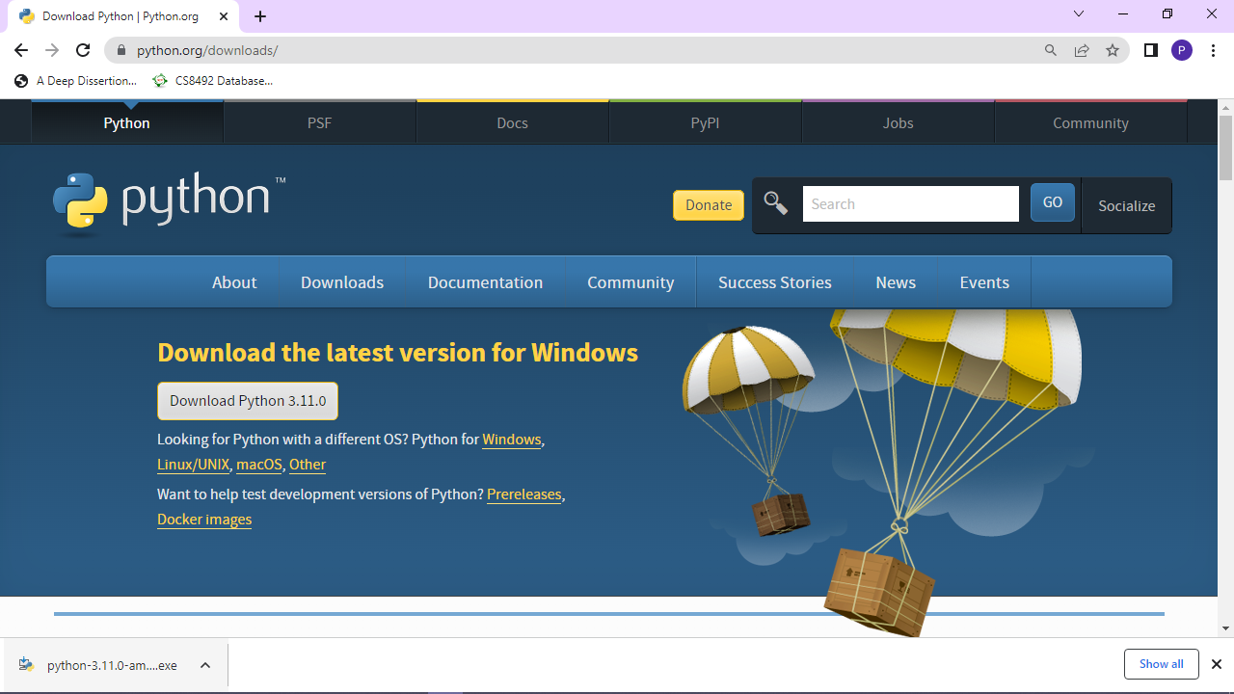

4.After clicking python-3.11.0-amd64.exe, it Start the Setup Progress

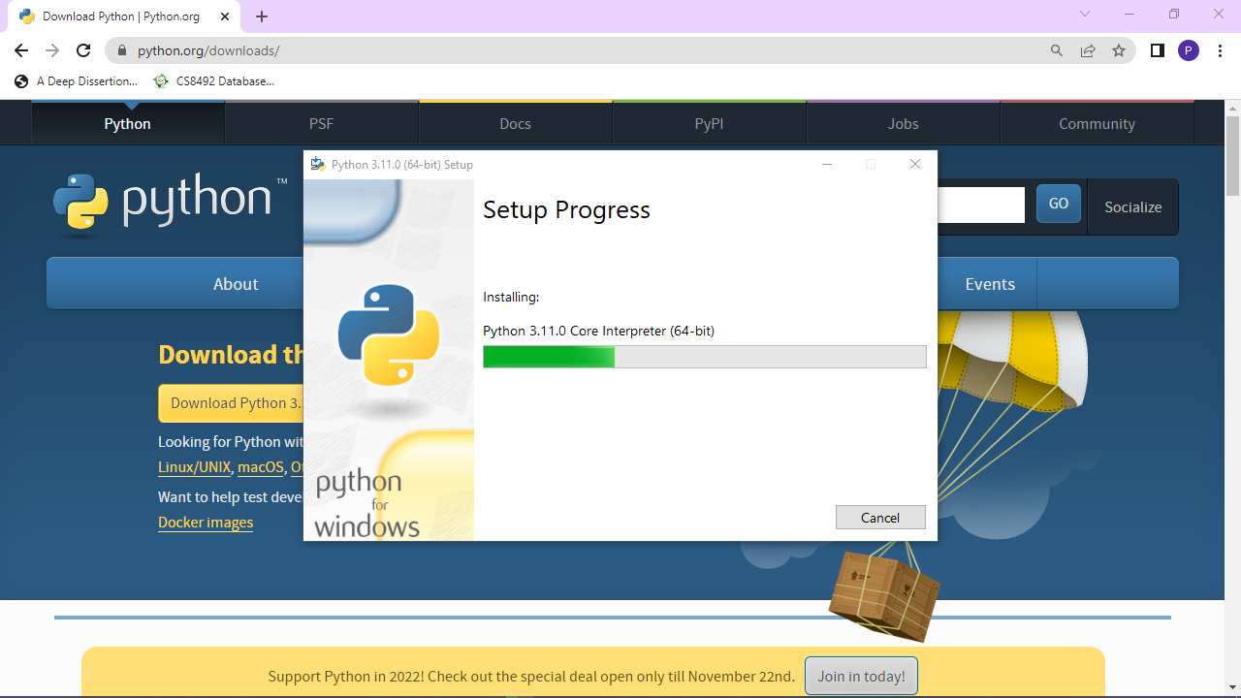

5.Once completing the setup progress, it display as **Setup was successful** as below.

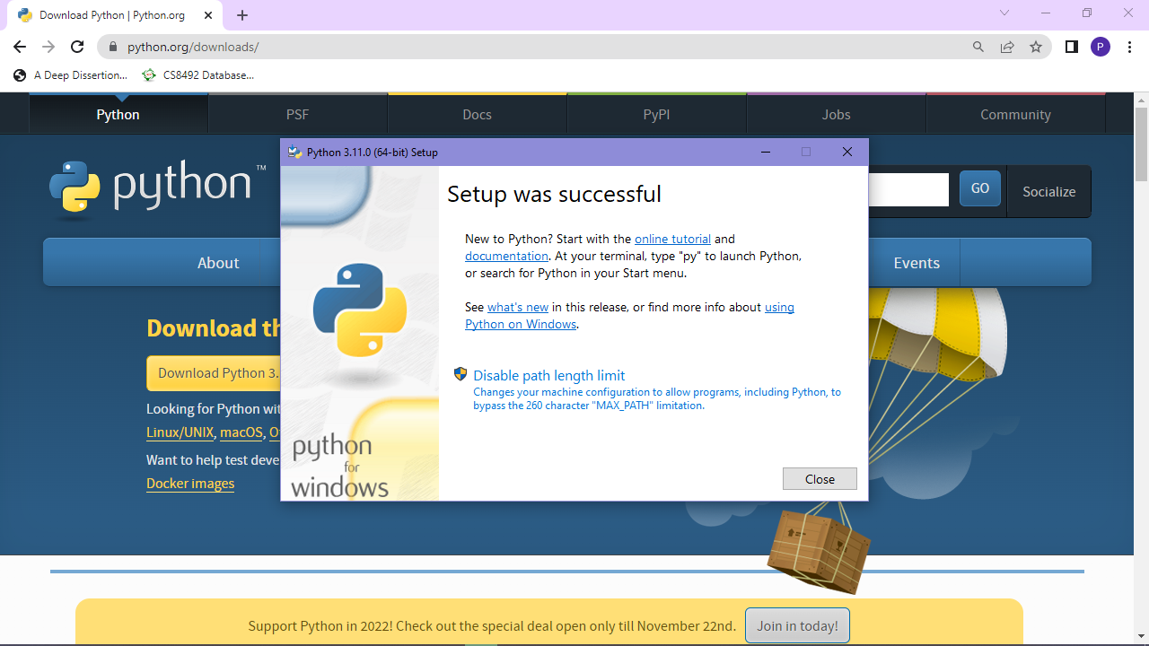

6. Now , i have successfully installed the python software.

